GFWC MEMBERSHIP “THE
REAL DEAL”
GFWC Membership News
Jeanne Waseleski Membership Committee
Editor: Penny Peterson
GFWC 2016-2018
Like us on Facebook at

November-December 2016
GFWC Membership-The Real Deal

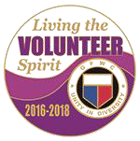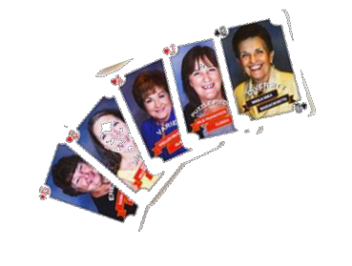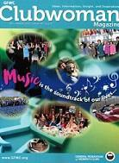
A PROSPECTIVE MEMBER BECOMES A NEW CLUB MEMBER . . . WHAT’S NEXT?

What expectations await an individual who has just joined your club? The process you may use for welcoming members into your GFWC club is a membership orientation. The goal of a new member orientation is to help the member feel welcomed, integrated into the organization, and contributing successfully as quickly as possible.

Major objectives of orientation are to (1) gain member commitment, (2) reduce her anxiety, (3) help her understand the organization's expectations, and (4) convey what she can expect from being a member of your club.

In your organization, a core of information exists that you need to share with every new member. New member orientation generally contains information in areas such as:
• Membership Benefits of belonging to GFWC
• Structure of the organization
• Club History
• Rules & procedure – Club bylaws
• Review Duties of Officers/Chairmen
• Club’s current programs and goals
• Club communications via newsletters &
emails

This information above may be provided as part of your general club meetings, at a series of special meetings, or on a small group or individual basis. It is not as effective to disperse all this information at one time.

Do not wait for new members to always ask questions . . . be pro-active and anticipate their needs. Take a minute and think about your first meeting . . . put yourself in the shoes of a new member again. Remember, a well-informed member (new and current) enhances and provides for an efficient and organized group of volunteers working together for a common goal.
Need a Last Minute Gift Idea?

Give a subscription to GFWC Clubwoman Magazine The official publication of GFWC Price: $10/year

The Real Deal Membership
Playing Cards - $5.00
Available at the GFWC Marketplace

The GFWC “Real Deal Membership” playing cards were introduced at the recent GFWC Region Conferences. The cards feature clubwomen from various locations and their description of what GFWC means to them. A deck of the playing cards may be purchased through the GFWC marketplace. Use them at your card parties or other social events to generate and promote conversation about the benefits of being a GFWC member. Utilize them as a tool during your membership orientations.

Idea for a club activity
Consider creating your club’s own personalized deck of playing cards. Give each member a blank card. Have them draw or glue a picture
of themselves on the card. Then ask your members to
write their own description of what GFWC means to them. Or you may have members write on the card a response that can be shared with the other members, such as how they were introduced to federation and their years of membership or their favorite club activity/program.

Please share how you utilized the “member playing cards” within your club with the GFWC Membership Committee.

Spring seasonal recruitment
GFWC MEMBERSHIP GRANTS
Application deadline is March 1, 2017.

GFWC’S “IT’S THE REAL DEAL”
RECRUITMENT CAMPAIGN
December, January, February
GAME OF HEARTS - Report due March 1

