GFWC/CT Member of the Month March 2017

Shirley Barnes
GFWC Northeastern CT Woman’s Club
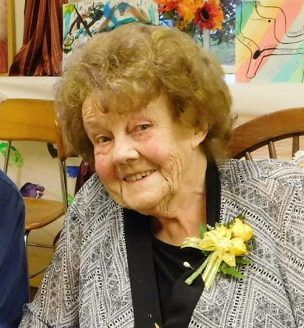

How long have you been member and why did you join? My first club is in Massachusetts. I have been a member at least 70 years. You could say I was born into it: my Mother and my Grandmother both were members. When I was a high school junior, I was chosen to be an honorary member. I just stayed with it because my family was all in. I joined my Connecticut club because I was asked to join.

Are there any projects you have worked on that you are proud of? The club worked with the Historical Society and the Church – cooperative events for the community. One was a fashion show with antique clothes. Mrs. Rod had a collection of antique clothing and we each had to model and tell about the era for our clothes. That was fun.

Do you have friendships that have come out of your involvement in GFWC? Oh yes. There are people I would never have known if I had not been in the club, people from town and from other parts of the state. I have become a better friend with one of my classmates because of Woman’s Club.

Do you go to Region or State meetings? I like them even better than local ones. They have a broader interest and you get to know many more people. With the State, you get involved with many things that are beyond what your town is doing. I like being in the (GFWC) Gold Nuggets – that’s a really broad interest. They are a Club that helps raise money so the women from GFWC Alaska can come down to their Region and International meetings. It is quite expensive for those trips. Because of that club I have been able to go to California and Alaska with GFWC.

Did you ever go to the International Convention? Oh yes. It was an eye opener. I was surprised at the people I met. These nice, friendly women who were brilliant. These women had good business jobs, careers. Yet there they were in the Woman’s Club. And you learn from them.

What could our club do to get some of these women involved with us and join GFWC? Maybe we could do a project that is an area they are interested in. You could ask them for help, support their interests, and maybe they would be interested in staying with the club.

