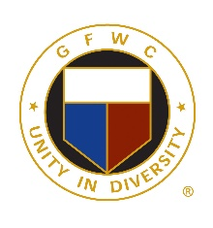
GENERAL FEDERATION of WOMEN’S CLUBS of CT, INC.
We Rise by Lifting Others
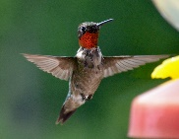
Call to North Central District Day
Saturday, April 9, 2022
Grassmere Country Club
130 Towne House Road
Enfield, CT 06082

9:00 REGISTRATION
9:45 BUSINESS SESSION
Welcome and Credentials
Introduce GFWC/CT State Officers
Present GFWC Awards
Reports of Club Presidents
11:00 SPEAKER – Bonnie Waterhouse – ‘Truth and Myths about Ticks and Lyme Disease’
11:30 SOCIAL TIME
12:15 LUNCHEON
1:30 MUSICAL ENTERTAINMENT
2:00 REPORT of the Nominating Committee
INSTALLATION of new officers for the District
2:30 RAFFLE

GFWC/CT - NORTH CENTRAL DISTRICT DAY – April 9, 2022
LUNCHEON BUFFET
Pasta with Marinara Sauce Chicken Francaise
Italian Style Meatballs Seasonal Vegetables
Roasted potato Fresh Garden Salad
Baked Scrod Warm rolls
Cookies and Brownies – Coffee and Tea

FEE $32.00 – Includes - $5.00 Registration Fee - $27.00 Luncheon
Checks payable to - Northeastern Connecticut Woman’s Club
Mail to: Kathy Barnes
653 Shenipsit Lake Road
Tolland, CT 06084
DEADLINE for RESEVATIONS IS March 30, 2022
Name of Club (or) GFWC/CT State Officer____________________________

Person Making the Reservations _____________________Tel.#_____________
Please enclose one (1) check for $_________ for ________ reservations
PLEASE PRINT NAMES
____________________________________________________________________________________________________________________________________________________________________________________________________________________________________________________________________________________________________________________________________________________________________________________________________________

