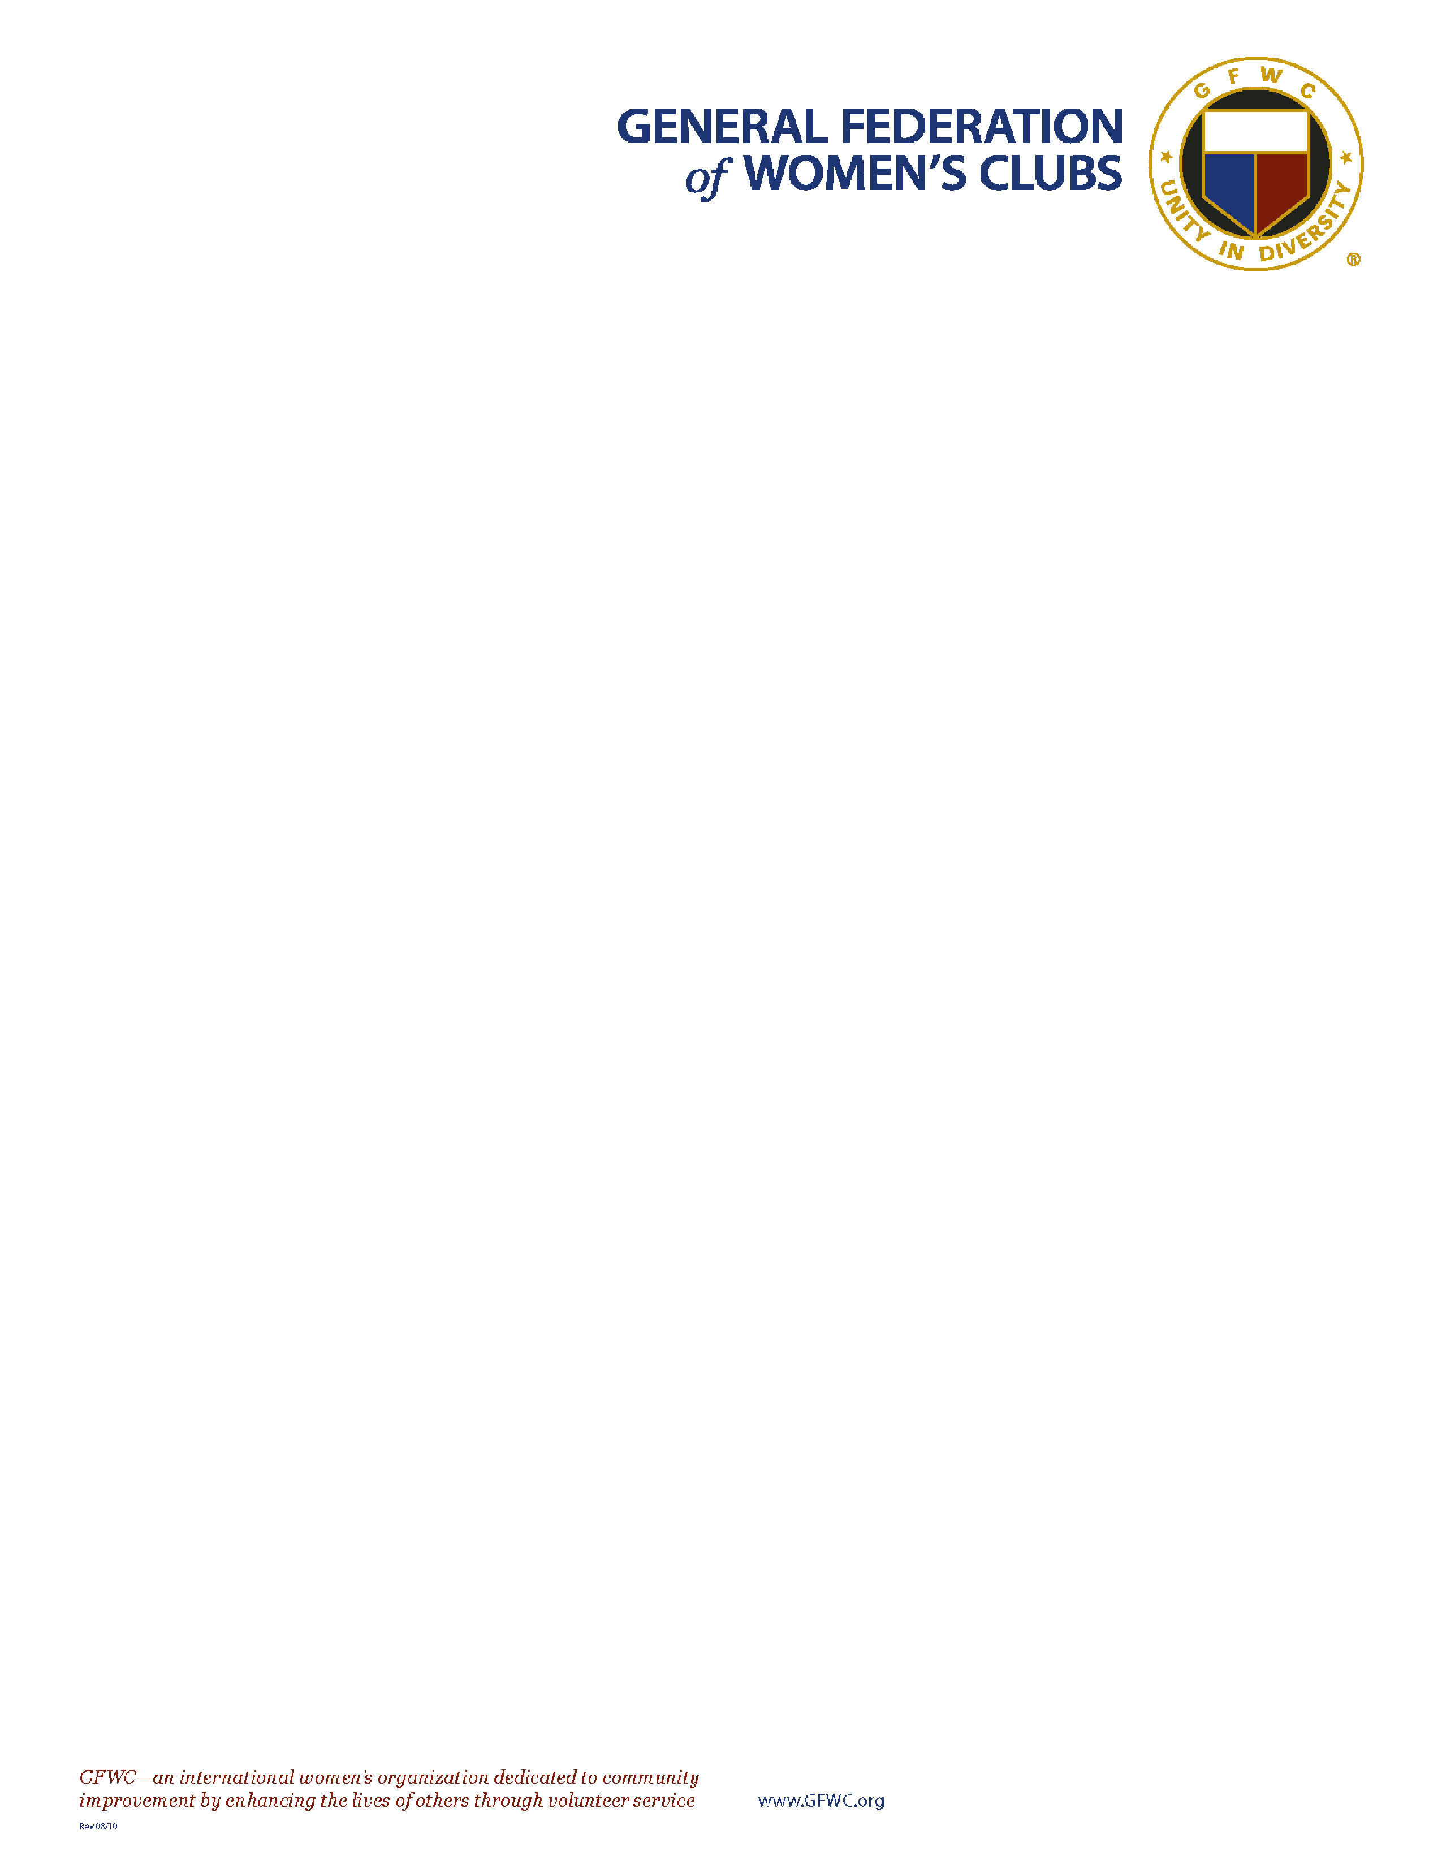

Dear Fellow Members,

Welcome to the 2022

-

2024

GFWC Administration. I am humbled and

honored to serve as your 54th GFWC International President. Please join

me in embracing the leadership and service opportunities that will be

ours over the next two years.

Your state public

ations and the GFWC Club Manual will play an essential

role in the success of your programs and projects as they are wonderful

tools and resources for you and your clubs. Be sure to network and call

upon your state leadership when needed! They are there

for you and

want nothing more than for your club to flourish and grow.

The 2020

-

2022

Administration taught us many valuable lessons. What was the most notable? We learned

NOTHING stops a GFWC Clubwoman!

In preparing for this administration, my hope f

or GFWC is to continue strengthening the many facets of

membership, leadership, and communications necessary to ensure the future and sustainability of this

organization.

I also wish to thank you, our dedicated GFWC members, for continuing the vital work

of our volunteers in our

local clubs and communities. Always remember every gift you share as a member of GFWC has

tremendous value and significance.

The common bond of compassion, service, and philanthropy connects us all, no matter how young or old we

are and no matter where we live. Through the giving and sharing of GFWC, we discover its true reward.

So together, let’s Dream Big…Sparkle More…and we will indeed Shine Bright, for the Federation’s greatest

gifts are all of YOU, the timeless, priceless

members of GFWC!

Continue

*Living the Volunteer Spirit*

.

Yours in Federation,

Debra A. Strahanoski, GFWC International President

