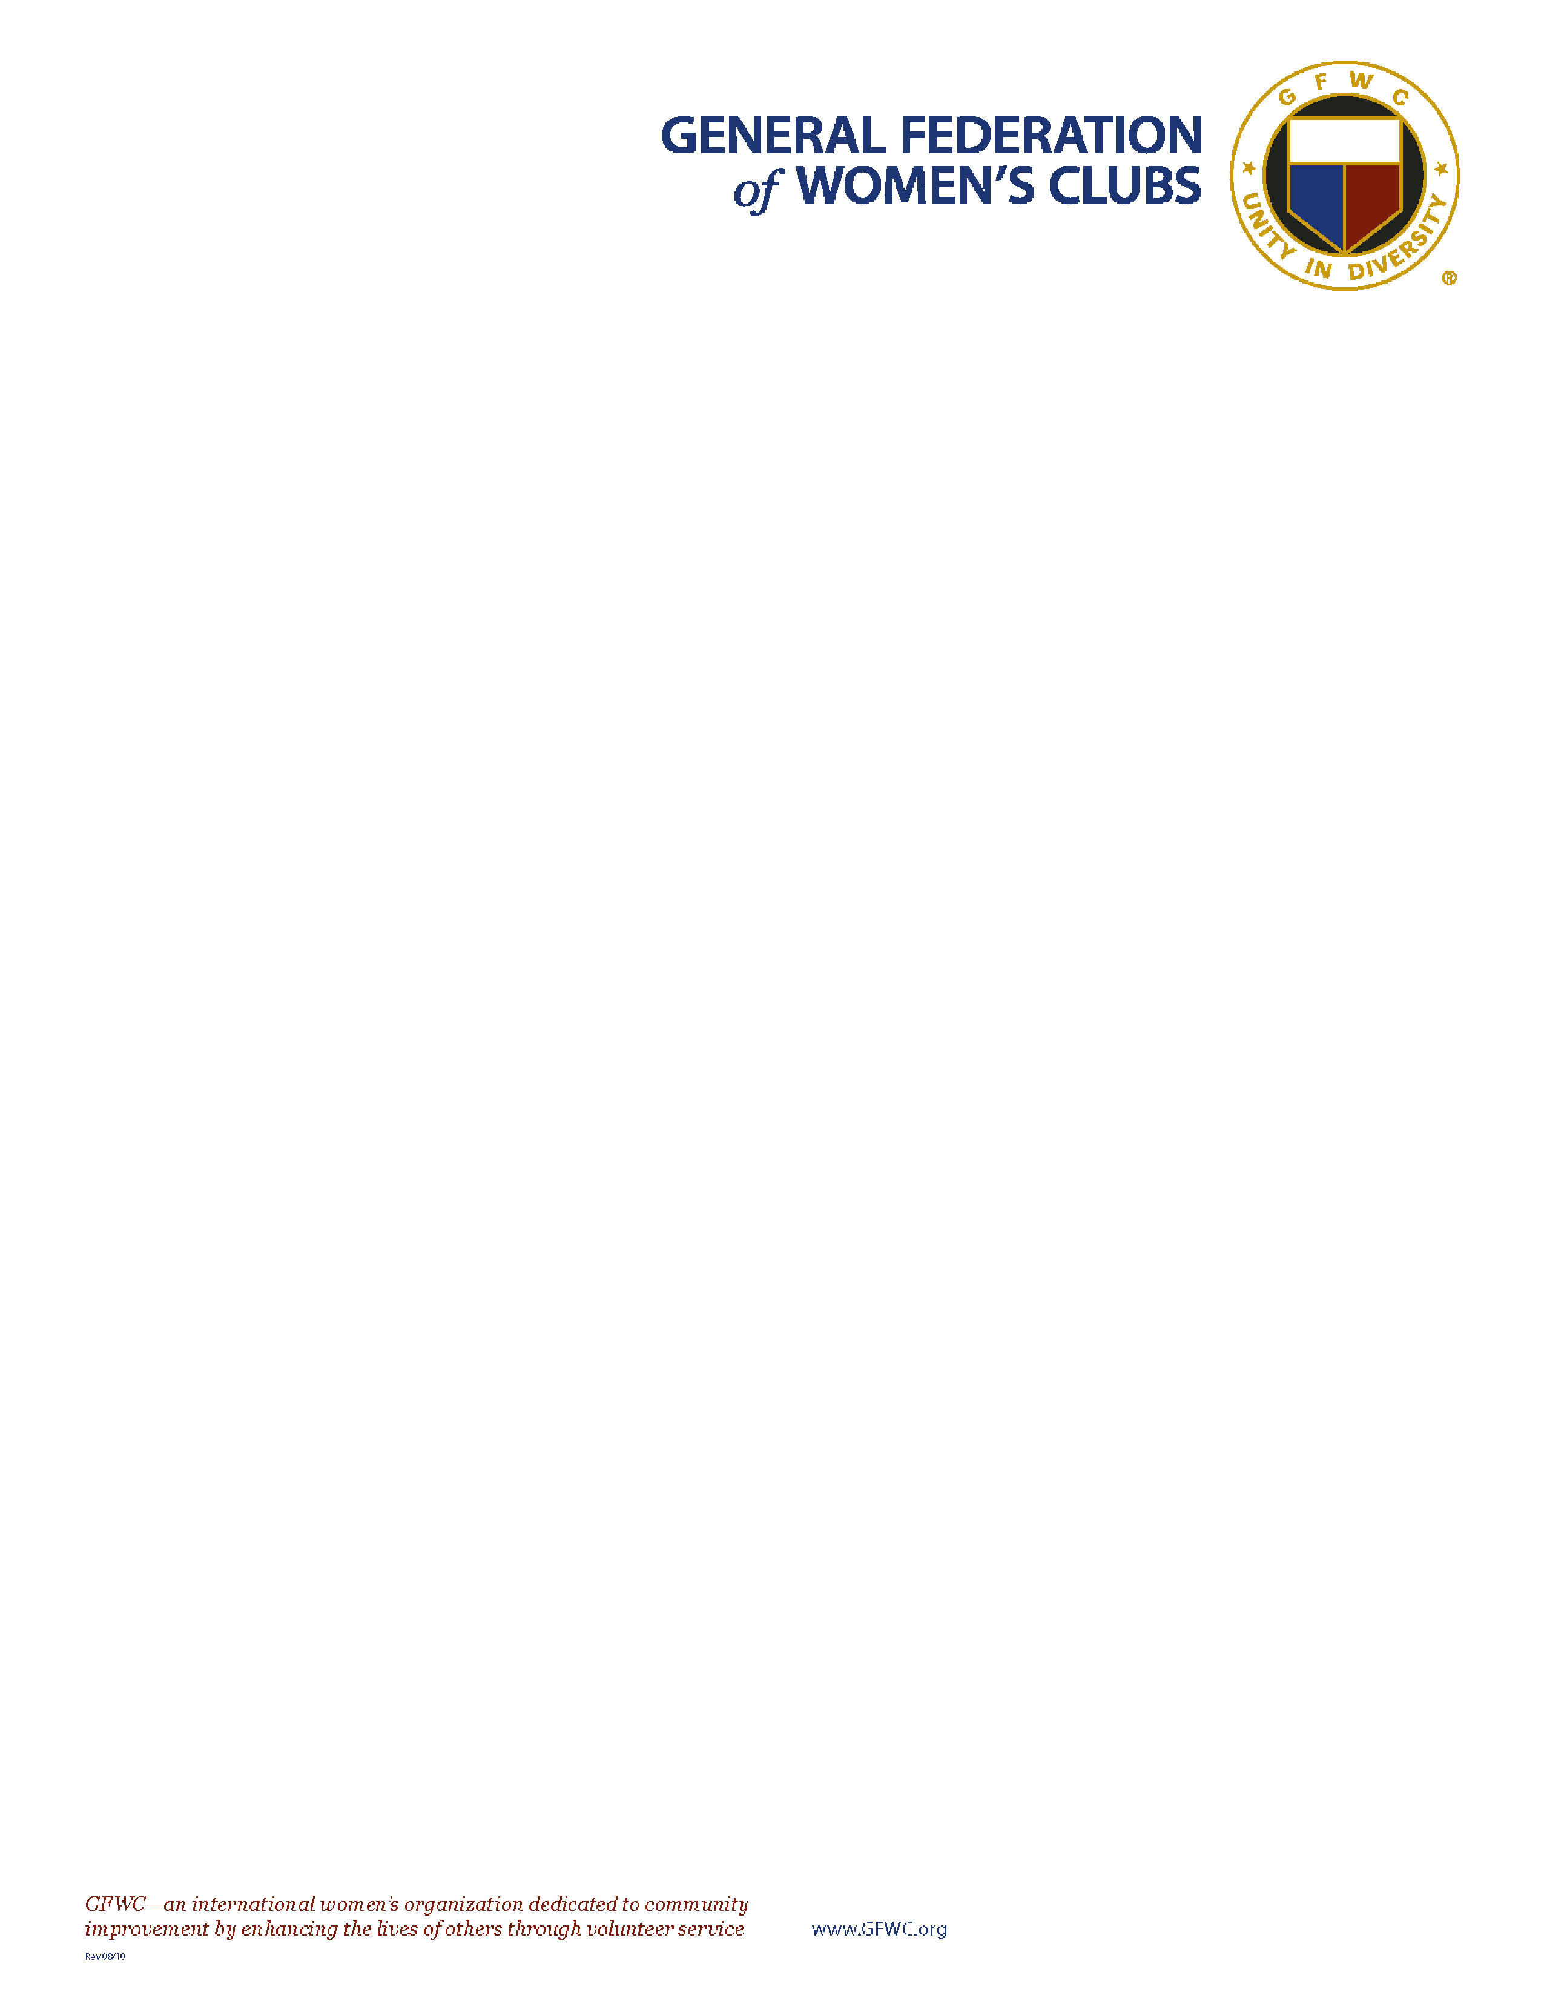

Dear Fellow GFWC Members,

What an honor it is to welcome you to the 2022

-

2024

Administration as the

36

th

GFWC

Director of Junior Clubs! I look forward to serving alongside you all as we continue the

work of our fore sisters. From 90 years of Junior membership to 100 years in our beautiful

home at 1734 N Street, we will have many reasons to celebrate

*togeth*

*er*

!

The guiding concept for the Junior Administration will be to “

**Share your Sparkle**

”. We

know all the great things our members do

-

we need to share them with the world!

**S**

ervice

-

Give back to Others!

**P**

assion

-

Find what you love!

**A**

dvocacy

-

Speak up for

those who can’t!

**R**

epresentation

-

Vote & Join the Legislative Center!

**K**

udos

-

Brag on your members, club, state, and GFWC!

**L**

eadership

-

Develop members at the club level!

**E**

xcitement

-

Tell your friends, family

,

and community what all GFWC is about!

Advocates for Children continues to be the Junior’s Special Program. We will encourage clubs to plan projects for their

favorite local organizations and/or March of Dimes, St. Jude’s, and Prevent Child Abuse Ameri

ca. We will celebrate

Advocates for Children Week the fourth week of October. The emphasis of Advocates for Children Week will be to

promote a collection of personal hygiene items, clothing, and blankets to local organizations benefitting children remove

d

from homes due to unsafe conditions. We encourage

all

clubs to participate and Share Your Sparkle!

When you “

**Share Your Sparkle**

,” your passion, drive, and dedication shine to all. Let’s use the best tool we have of all to

promote GFWC

-

*OUR MEMBERS*

!

In Junior Love,

Katie Moydell, GFWC Director of Junior Clubs

