2022-2024 GFWC
LEADERSHIP COMMITTEE

Susan Gettys, Chairman
GFWC Mississippi Valley Region
susan.getts@att.net

Candi Aubin
GFWC Southern Region
aubin5@aol.com

Deb Brossard
GFWC Great Lakes Region
deb.brossard@gmail.com

JoAnn Calnen
GFWC New England Region
jcalnengfwc@cox.net

Jan Hanson
GFWC Middle Atlantic Region
janwh@aol.com

Ann Landis
GFWC Southeastern Region
alandis@ec.rr.com

Betty MacMaster
GFWC Western States Region
macmaster@harbornet.com

Suzanne Simons
GFWC South Central Region
srsimons@mac.com

Welcome to the GFWC Leadership Committee Newsletter - Embracing Leadership. We plan to share leadership articles, top ten projects, toolkit highlights, the book for our next Leadership ESO Book, and the timeline for the discussion. Other features will be added as needed.

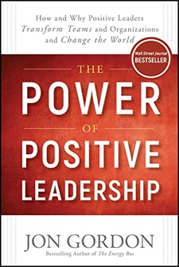
Our first Leadership ESO Book is The Power of Positive Leadership by Jon Gordon. This book is filled with proven principles, compelling stories, practical ideas, and practices that will help anyone become a positive leader. We invite you to read this book with us and join us on September 25 at 8 pm ET (7 pm CT, 6 pm MT, 5 pm PT) for a Zoom book discussion. The Zoom link will be posted in the GFWC Advancements and Programs Forum a week before the discussion.
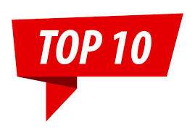Sharing Club Leadership
GFWC Woman’s Club of Martinsburg (WV) provided leadership seminars that included historical information and an overview of duties. Each member completed a monthly responsibility at the club meetings, which engaged all members in building leadership skills and preparing for the club’s future.
What a great way to build leadership skills in all your club members! Check out the Member Portal at gfwc.org to find the list of more Top Ten Projects.

PLANNING YOUR STATE LEADERSHIP EDUCATION AND DEVELOPMENT SEMINAR (LEADS)
There are many options for planning your State LEADS Program:
- Schedule a full-day meeting at a time separate from your state convention
- Plan a half-day session different from your state convention or the day before the convention
- Reserve a two-hour block the night before the state convention begins
- Book an hour before your convention begins, maybe scheduling two days in a row and dividing your content between the two days.
- Organize a short LEADS session to be delivered during the day of your convention for everyone attending the convention to hear.
There are many ways to bring Leadership Training to the club members in your state. Think outside the box in planning your timeframe.
Next month, we will share topics you might want to feature in your State LEADS Program. Visit the GFWC Member Portal and check out the Leadership Toolkit. There is a new section with sample agendas that may help you plan. Presentations and scripts for specific topics will be added soon. Keep checking back!

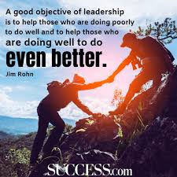

Have you joined the GFWC Advancements and Programs Forum on Facebook?
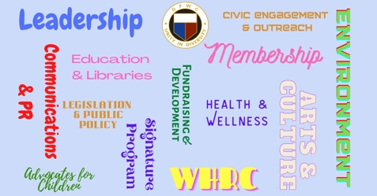

The GFWC Communications and Public Relations, Leadership, and Membership Advancement Chairmen administer this private Facebook group. They will share tips, strategies, and real-world tools for you to strengthen and grow your local clubs. Here you’ll have access to monthly live mini-workshops, live video streams, interviews, live Q & A’s, and daily posts designed to help support, inspire, and empower our membership.
Click on the Join tab at the top of the page, and don’t forget to answer the three membership questions to verify your membership in GFWC. We look forward to seeing you on the Forum.
Beginning in September, Teach It Tuesdays will offer monthly videos with topics from the Forum poll in the areas of GFWC Communication/Public Relations, Leadership, and Membership. Also, starting in October, a new set of videos, Thumbs Up Thursdays, will feature other GFWC Chairmen or Board of Directors members.

NEW! GFWC National Event

How can you build/strengthen the GFWC brand in your community? How can you thank individuals and businesses who have supported your past club projects? How can you share the impact your club has made on your community?
Host a GFWC Friendsgiving event! This is a new national event promoted by the Communications/PR, Leadership, and Membership Committees. Your event could be held at any time of the year and developed around the theme of your choice.
A GFWC Friendsgiving ~ Box of Gems has been created with all the documents and resources you need to host your own GFWC Friendsgiving Event. These resources are in the F Resources Folder in the Member Portal.
Enjoy planning and hosting your club’s event. Share the success of your event in the GFWC Advancements and Programs Forum on Facebook.

