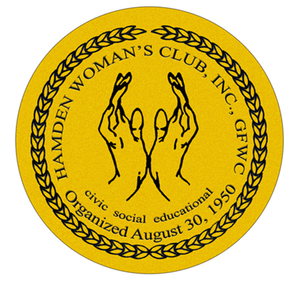
Hamden Woman’s Club

Invites you to a Pizza, Soda Party
Welcome Back to our HWC Members and Greet Prospective Members.

Place:

Hamden Senior Center

November 2nd

at 5:30pm

Hamden, CT. 06518

COST: $5.00 per person,

FREE FOR PROSPECTIVE MEMBERS

