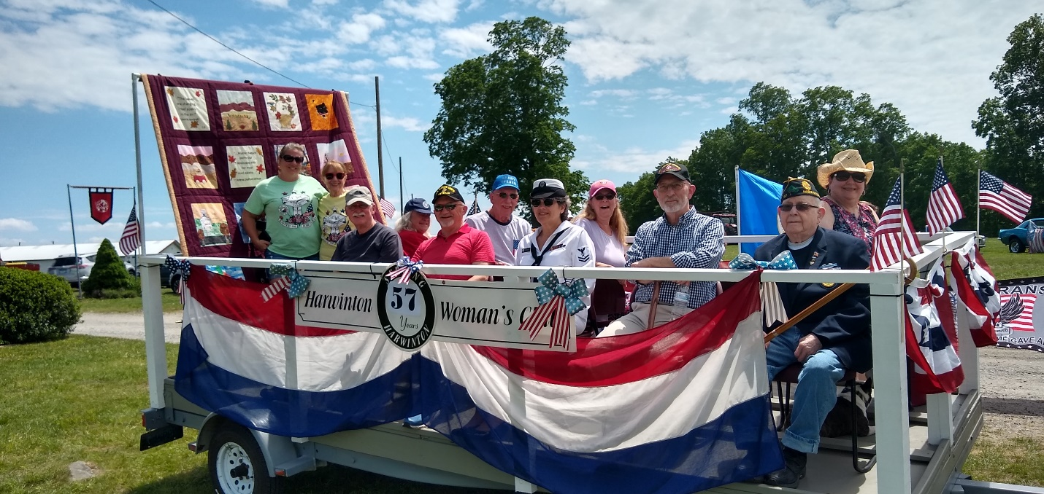
The GFWC HARWINTON WOMAN’S CLUB
2022 Memorial Day Veterans Float
The GFWC Harwinton Woman’s Club is privileged every year to carry on our float, our veterans in the Memorial Day Parade. This year we were honored with eight veterans and three HWC members. We also showcased our upcoming forty-eighth hand-stitched quilt called “Fall Colors”.
In 2021, a hometown Eagle Scout took a boat trailer and turned it into a 10-seat veteran’s float specifically for the parade. Seats can be removed where wheelchairs can be rolled on should that need arise.
We are thrilled to carry our 99-year-old veteran, James Bement who served in WWII (front row, far right).
God Bless our Veterans both Then and Now!
GFWC Harwinton Woman’s Club * PO Box 103 * Harwinton, CT 06791
MADELINE B. MARZULLO, President HWC (Veterans Chair)
194 Harmony Hill Road * Harwinton, CT 06791 - 860-689-4395
25 October 2022
Honor Flight Connecticut
c/o Matt Sparks
27 Twin Oak Trail
Beacon Falls, CT 06403

Dear Mr. Sparks and HFCT
The GFWC Harwinton Woman’s Club is donating in the amount of $500.00 to send a WWII veteran (if possible) to Washington DC on your next Honor Flight out of Bradley International Airport, CT. If no WWII Veteran, a Korean Veteran, or a Viet Nam Veteran.
The folks in our community purchase a flag(s) for $10.00 every Memorial Day honoring a Veteran. A Ribbon is attached to the flag indicating Name, Rank, Branch, Years and Where served if known. These flags are planted in our Town Green garden. After our parade they may come and take their flag to place wherever to honor said Veteran.
With funds we have collected these past 14 years, we donate every year to the different veteran’s organizations to help them the best we can.
It is our honor this year to donate to “Honor Flight Connecticut”.
God Bless our Veterans Then and Now,

GFWC

The General Federation of Women’s Clubs is an international women’s organization dedicated to community improvement by enhancing the lives of others through volunteer service. Collectively, we are Living the Volunteer Spirit.

