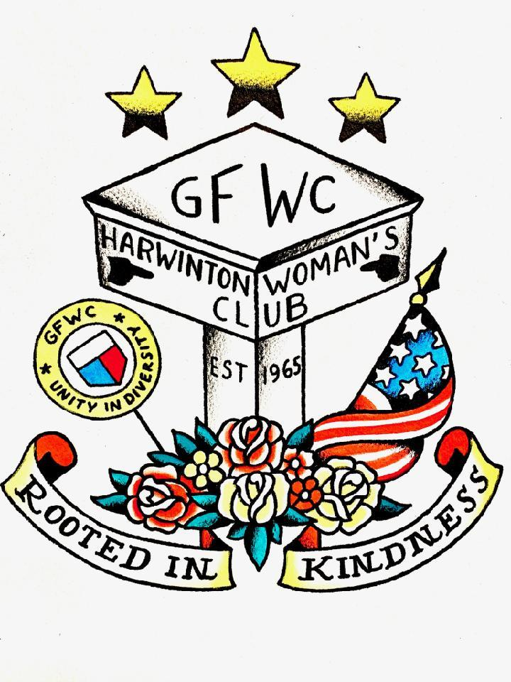
MEETING
7:00 PM Wed., Jan. 4, 2023
Harwinton Town Hall

Program: Travel Talk
with Carol & Kevin Stiles

GFWC The Harwinton Woman’s Club
News & Views – JANUARY 2023

FROM OUR VICE PRESIDENT
Hi everyone,
Our December 7th meeting was an enjoyable one. Thanks to Michelle, Nancy, Pat, Maddy, Sue Ryan, and Sue McClen for providing the delicious goodies. The holiday games, Pass the Trash and the Quarter Challenge, were fun and successful. Members brought some amusing “trash” which allowed for trading throughout the game. We filled the tube with quarters and decided to donate the proceeds, which were matched by the club treasury, to Mary McElwee, a former club member. Unfortunately, Mary’s house had sustained fire damage earlier that same day.
• Thank you to the committees for submitting reporting forms for submission to GFWC/CT to highlight projects you have completed throughout the year. Additionally, monthly updates to the membership have been informative and have given members opportunities of their choice to support your respective initiatives. We have been compiling the reports for submission to the GFWC/CT in early January.
• The Health and Wellness committee is hosting the Red Cross Blood Drive on January 14th. Michelle and Lois will be soliciting our help with the drive at our January meeting.
• Carol Stiles will be describing the craft opportunity for January. Thank you to Carol and her committee members, Amy Cypher, Kim DeDominicis, and Ashley Fowler for sponsoring the monthly Saturday craft sessions.
Continued on page 2

Congratulations to our members celebrating their birthdays or anniversaries!
JANUARY
Karen Fowler, January 3rd
Colleen Slason, January 21st
Lois & George Pelletier, January 29th

FEBRUARY
Joan Schoenemann, February 2nd
Nancy Eldridge, February 4th
Pat Green, February 5th
Destiny Vince, February 5th
Tina Hasapis, February 6th
Terry & Jim Zagryn, February 12th
Victoria Creighton, February 24th
Joan Gangloff, February 26th

2022-23 OFFICERS
President – Maddy Marzullo
Vice President – Pam Lazaroski
Corresponding Sec’ty - Nancy Eldridge
Recording Sec’ty – Holly Martin
Treasurer – Carolyn Kurtich
Ass’t Treasurer – Maddy Marzullo

Parliamentarian – Susan McClen

•
Also, Carol and Kevin Stiles will be taking us on one of their vacations.
Hope to see you at the first club meeting of 2023 on January 4th at 7:00 p.m. in the Assembly Room at Harwinton Town Hall. Happy Holidays! Pam and Maddy

CIVIC ENGAGEMENT & OUTREACH
Thank you to those of you who supported the Susan B. Anthony Project Wreath Fundraiser. Between sales and a $50.00 donation, we made a payment of $935.00 to them. They also appreciated the donations of food items for the Domestic Violence Vigil even though it was twice cancelled. People at the shelter enjoyed the refreshments.
We will be participating in the Susan B. Anthony Project Adopt a Family for the Holidays. If you are willing to participate in this project, please purchase gift cards redeemable at local stores such as Target, Walmart, Kohl’s, etc. They ask that they be in $25.00 increments, if possible. You might want to team up with somebody to offset the expense.
We are continuing to collect non-perishable items for the Harwinton Food Bank. They would especially appreciate the following: Tuna fish, cereal, jelly, peanut butter, any condiments, fruit, pancake mix, canned pasta, toiletry items (especially toilet paper and paper towels). Please consider bringing items to the December 7th meeting or you may drop items off directly at the food bank any time throughout the month.
As always, thank you for your support and generosity. Pam and Holly

CIVIC ENGAGEMENT & OUTREACH
Thank you to all of you who provided gift cards for the family our club adopted for the Susan B. Anthony Project Adopt a Family for the Holidays.
We are continuing to collect non-perishable items for the Harwinton Food Bank. They would especially appreciate the following: Tuna fish, cereal, jelly, peanut butter, any condiments, fruit, pancake mix, canned pasta, toiletry items (especially toilet paper and paper towels). Please consider bringing items to the January 4th meeting or you may drop items off directly at the food bank any time throughout the month.
We are in the process of planning a community outreach project with the Lewis Mills Humanitarian Club student members for this spring. Stay tuned for further details.
As always, thank you for your support and generosity. Pam Lazaroski and Holly Martin

VETERANS
Thank you, ladies, for your gifting donations for our Veterans for Christmas. Some went to Wolcott Hall and the remaining to Litchfield Woods. They were both extremely thankful for our contributions.
Wishing you all the very best for a Healthy and Happy New Year.
Candy Jones, Carol Smith, Wendi King, Maddy Marzullo

ARTS & CULTURE
Arts committee met and made Christmas cards on Saturday December 10th. Some really nice cards were made!
Come join the Arts & Culture monthly get together this month to create some beautiful painted skies on muslin fabric. These creations may be utilized by this year’s quilt patch makers in their creations for our "Rooted in Kindness" 2023 quilt. All are welcome. This is a simple, fun project.
Date: January 21st, Saturday ---Time: 2:00-4:00 P.M.
Place: Founder's Congregational Church
Bring a friend along too!

Also, don't forget about our Members' Annual Arts & Crafts show to be held at the March regular meeting. The following categories will be included: Ceramics, digital art, drawings, paintings, photography, fiber/textiles, metals, jewelry, mixed media, wood, miscellaneous, etc.
Actually, anything you've created can be entered. So, no excuses, bring something! Show off your talents.
And, the biggest prize of all will be the memberships choice award voted on by all who are present.
Arts and Culture Committee members, Carol Stiles, Kim DeDominicis, Ashley Fowler and Amy Cypher

HEALTH & WELLNESS
The Health & Wellness committee is hosting the Red Cross Blood Drive on January 14th. Please see Michelle and Lois at our January meeting to help out with the drive.

QUILT PROTOCOL
QUILT PROJECT 2023! Grateful. Thankful. Blessed......Yes, we are as plans are coming along. Ideas are popping up. it will be a very thoughtful, meaningful and beautiful MADE IN HARWINTON QUILT. We will be gathering in January to share our creative thoughts.
Other quilt news: Martha Lecko of the Historical Society has stepped up to work on the Brass labels of the Harwinton Town Quilt and the Let Freedom Ring Quilt Plaques. in the Town Hall. Editing was needed to fit the most important words. She is working with the Plaque expert as well. The Historical Society feels our quilts are very important and need more attention. RIGHT! submitted by patgreen

EDUCATION & LIBRARIES
No report this month.

ENVIRONMENT COMMUNITY SERVICE
No report this month.

GFWC/CT
State President’s Project: Katherine DeBurra, Connecticut
GFWC Connecticut State President Katherine DeBurra’s Administration theme is “Individually we are one wave, Together we are an ocean!” Katherine selected the symbol of the ocean to honor her home club in Madison, CT, which she has been a member of for 33 years, since it is near the shoreline. In addition to this theme, her president’s project focuses on women’s health and wellness. She said when women’s bodies are healthy, they have more positive energy and can achieve many goals together.
Clubs are encouraged to promote healthy programs and topics and to use the theme GFWC Get Fit Within Communities! The March 2023 State Meeting will be titled, March Into Health!, and the programs for that meeting will focus on health topics from member’s suggestions.
Katherine hopes to receive input from members and engage them in planning throughout her Administration. She feels that since people everywhere are coming out of some very unusual and abnormal times during the COVID-19 pandemic, now is a time for getting back to normalcy and connecting with fellow members. Already having held a state board meeting in July and a fall conference in September, both well attended, Katherine is now considering a variety of venues, such as museums and other alternative locations, for future meetings.
During her Administration, Katherine also hopes to guide members into more leadership roles and opportunities. Dedication and growth to membership, including the recruitment of new members and retaining current members, is paramount!
Winter Clubwoman Magazine Available for Download
The 2023 Winter GFWC Clubwoman Magazine is now available to all members digitally in an easy-to-print, single-page format. The issue is available on www.gfwc.org under the News & Publications drop-down menu and will be archived with all other digital issues in the GFWC Member Portal’s Digital Library, under “C” in the “Clubwoman Magazine” folder.
Download the 2023 Winter Magazine and join us in celebrating the holiday season! This issue features a look at the holiday traditions of GFWC International Clubs around the world, an inspiring feature from Starfish Project, a look inside the Women’s History and Resource Center, previews of the 2023 GFWC Annual Convention in Louisville, Kentucky, and the 2023 Women’s History Month Event, and so much more.

UPCOMING EVENTS
1/14 – Red Cross Blood Drive at Town Hall
1/21 – Create beautiful painted skies on fabric at Founder’s Church from 2 to 4 pm.

TREASURER’S REPORT
MINUTES
Editor’s note: The Treasurer’s Report and Minutes are sent as a separate email attachment when the newsletter is sent out. Those members who receive the newsletter in the mail will receive a printed copy.

