General Federation of Women’s Clubs of Connecticut, Inc.
OFFICIAL CALL TO GFWC/July Board Meeting
WEDNESDAY, July 26, 2023
Katherine DeBurra, State President; GFWC/CT 2022-2024

Individually we are one wave, together we are an ocean!

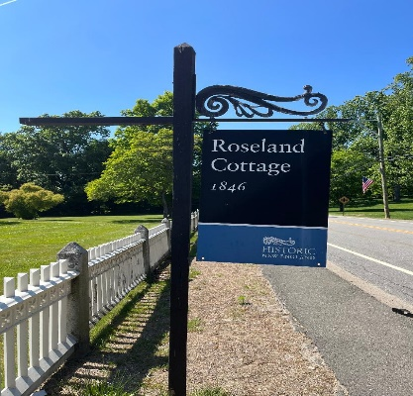
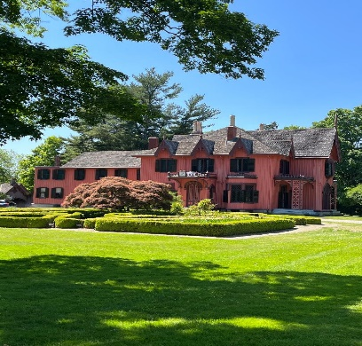

The July Board Meeting will be held at Roseland Cottage
556 Route 169 Woodstock, CT 06281-0186

The July Meeting will be a TEA-rific relaxing afternoon tea time at the beautiful Roseland Cottage to honor our GFWC- Community Service Project area (CSP) of Arts & Culture.
You will become acquainted with the great lady of Roseland-Henry & Lucy’s granddaughter
Constance Holt. From the mid 1930’s to the mid-1960’s she held a tea for the senior class of Woodstock Academy just up the street which was a rite of passage for Woodstock students. The tea will be served with a recollection from Miss Constance and this bygone mid-century tradition-no matter when you graduated! After the tea- groups of Members will tour this remarkable house that 3 generations of Bowens called home, with a special look at Miss Constance’s time at Roseland Cottage. The entire grounds are reserved for just GFWC/CT Members as we were invited to enjoy this wonderful opportunity on our reputation for doing wonderful work! We will meet the newest Executive Board Member; Nicole Karalli who was appointed as 3rd Vice-President as Wendy Clery moved into the 2nd Vice-President position to complete this administration.
Their time and dedication to GFWC/CT is most honorable!

Laurie Masciandaro; Site Manager of Roseland Cottage sends this message-“Miss Constance required hat, gloves, and dresses (preferably pink) for the girls, and Sunday best for the boys! We do not!”

For those who would enjoy a friendly competition we will have a hat contest-each person who chooses to wear a hat can donate $2 and the Members can select the winner to benefit!

ALL GFWC/CT MEMBERS ARE WELCOME AND ENCOURAGED TO ATTEND THE MEETING!

GFWC/CT Executive Board Members, Club Presidents, Chairmen of GFWC/CT Committees, Members of GFWC/CT Standing Committees, Community Service Program Chairmen, Past State Presidents, District Presidents, Assistant District Presidents, and State Officers.

Meeting room (Carriage House) opens @ 10:30 am.
Please allow the Convention Chairman and her Team
to have a little bit of time to make the room beautiful for you!

Parking is to the left of the Carriage House -in the back area where the tea and meeting will be held. Please car-pool if possible.

10:30-11:00 am Registration

11:00 am Call to Order; Welcome President Katherine DeBurra-with a special invitation
from the Prudence Crandall Center in New Britain for Hope Tours of the Prudence Crandall Center. A sign-up sheet of interest for a tour will be distributed at this meeting. Clubs can visit and or plan for Domestic & Sexual Violence Awareness month recognized in October with suggestions for projects.

Officers Reports-with a special focus on:

Kathy Barnes-President Elect; Leadership.
Wendy Clery- 2nd Vice-President; Reporting.
Nicole Karalli-3rd Vice-President; Membership.
Pam Lerner; Assistant Treasurer; Directory lists.
Anne Edwards; Member at Large; Suggestions from Convention.

11:30 Helen Barakauskas; Nominating Committee Chairman for the 2024-2026
Administration. Please see page in this Call for information on applying for a position, guidelines and deadlines.

Enhance the lives of others with your volunteer service by joining the Executive Committee !

12:00 Noon Tea-friendship and social time, with “Miss Constance!”

Tours of the beautiful home pictured on the front of the Call
will be done in groups as we finish our teatime.

The area and gardens are exquisite to stroll around.

2:00 pm Other Business/Club Program Announcements -Hat Contest Winner!
Jennie June Announcement!

2:30 pm Adjournment.

This area boasts antiquing and a few consignment shops that are well known if you’d like to poke around the area after the meeting in Woodstock.

Reminder: Connecticut hosts NERC this year!
New England Region Conference-Sept. 21-24, 2023 @ the Sheraton Hartford South Hotel, 100 Capital Boulevard, Rocky Hill, CT- Hotel Rate: $139

Call Marriott Reservations: 1-888-236-2427 or book online with Group Code: GFWGFWH
Or use link - https://www.marriott.com/events/start.mi?id=1685543185857&key=GRP

GFWC/CT Reservation Form for Wednesday, July 26, 2023
ABSOLUTE REGISTRATION DEADLINE: July 14, 2023

PLEASE SIGN UP TIMELY!

Registration: $10.00 Luncheon with program and tour: $40.00
Total: $50.00
There is a maximum number of attendees allowed by the Cottage personnel’s request, so please sign up timely as this may be a popular destination to enjoy a wonderful summer trip and a wait list will be added when the maximum number is reached.
If there is a long wait list -we will host another event as a fun trip!

This is a light tea luncheon with traditional cucumber sandwiches, chicken salad sandwiches, scones, cookies, 2 hot teas, iced tea. Gluten -free options are available.

Name____________________________________________________
Club_____________________________________________________
District: (circle 1) NC NW SE SW
Any Dietary Restrictions:______________________________________
GFWC/CT Executive Board Position: ________________________________________________________
Are you a 2022-2024 Club President? Yes____ No_____

There is space for table displays but there is also a maximum capacity for them in the carriage house so it will be first come first serve to allow enjoyment for all. No table charge to CSP Chairman or Committee Chairman, however, registration is required by deadline above please.

Mail Meeting and Table Registrations to:
Pam Lerner, 20 Brenton Terrace, Hamden, CT 06518
Contact Info: Phone: 203-281-3090 or pamlern41044@aol.com
Separate- checks (Registration or Table) made out to GFWC/CT. Thank you!

Half Table $5.00 - Full Table $10.00

Name______________________ Club_________________________
Email___________________________________________________

GFWC/CT NOMINATING COMMITTEE
COMMITTEE MEMBERS:
Helen Barakauskas, Chairman barkyhd@aol.com 860-626-3564
Ginny Chulkovs ginny.chulkovs@gmail.com 203-545-7996
Maureen Fernandes reendes@comcast.net 860-490-6385
Linda Melillo lillimel@sbcglobal.net 203-996-7495
Jeanne Waseleski auction46@comcast.net 860-302-2451
Alternates:
Sandy Allard sandyallard@gmail.com
Michelle Eifes michelleeifes@gmail.com
IMPORTANT DATES:
November 1, 2023 – deadline for clubs to submit names of endorsed candidates to the Nominating Committee
Early March 2024 – nominating committee to submit written slate of candidates for each office to the State President
OFFICES TO FILL:
Nominating Committee selects candidates for 1st, 2nd and 3rd Vice Presidents, Treasurer, Asst. Treasurer and Recording Secretary.
Corresponding Secretary is the choice of the President Elect and is included on the slate of candidates.
Member At Large is appointed by the President Elect and is not an elected position. This position does not appear on the proposed slate of candidates.
CANDIDATE ELIGIBILITY REQUIREMENTS:
Each candidate must be active member in a GFWC/CT member club and must be endorsed by her club.
Candidates for 1st, 2nd, or 3rd Vice President must have served on the Executive Board of GFW/CT and must have served as President of a GFWC/CT club.
ADDITIONAL NOMINATING COMMITTEE DUTIES:
The Committee must consider all club endorsed candidates. It should also consider additional candidates and seek club endorsement for those candidates.

