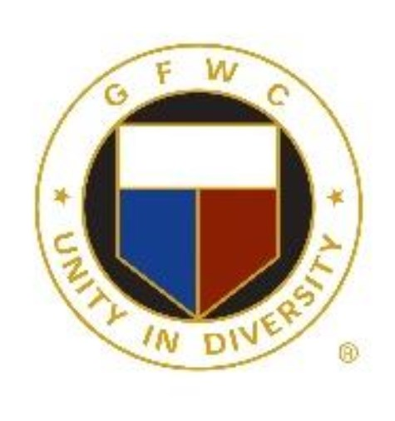
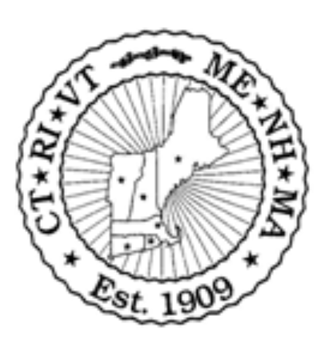
General Federation of Women’s Clubs New England Region

Connecticut – Maine – Massachusetts – New Hampshire – Rhode Island – Vermont

Libby Wiers, NER President

GFWC/CT, the Constitution State

Invites you to “The Greatest Show” in Connecticut
Let’s Dream Big, Sparkle More and Shine Bright

at the
114th GFWC New England Region Conference September 21-24, 2023

Sheraton Hartford South Hotel 100 Capital Boulevard, Rocky Hill, CT

Hotel Rate: $139
Call Marriott Reservations: 1-888-236-2427 or book online with Group Code: GFWGFWH
Or use link - https://www.marriott.com/events/start.mi?id=1685543185857&key=GRP
Hotel Deadline- August 23, 2023

GFWC SPECIAL GUESTS – ENTERTAINMENT – SPEAKERS – RAFFLES – SHOPPING – FRIENDSHIP

