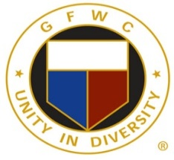
GFWC/CT is inviting you to an online fundraiser for GFWC Jewelry. This is an online sale and will run from October 28, 2023 to November 28, 2023. The website to purchase these very pretty and affordable items that are usually only available at International Conventions is: www.ladyjayne.com.
There are 5 items that are pictured on the website but Jayne can modify your personal requests and mix and match pieces to your style. Her website provides contact information and her email is sales@ladyjayne.com
Please mention our special code for preferred pricing as GFWC/CT.
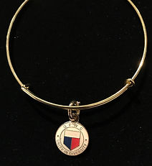
Here are three samplings of the very affordable pricing and very pretty pieces that she designs!

Expandable bracelet $39.95
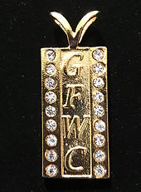

Dog tag style $39.95

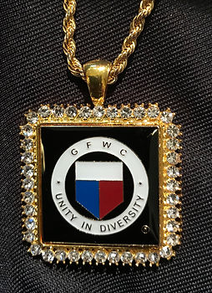

Square Medallion $59.95

Thank you for the support to GFWC/CT and
enjoy your beautiful pieces !
Please remember that the sale closes promptly on November 28, 2023 at midnight!

