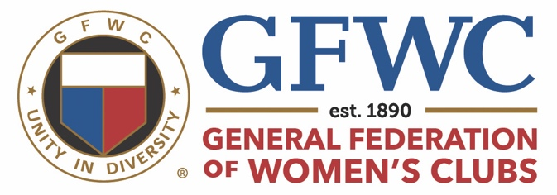

GFWC/CT LEADS 2024
Leadership and Development Seminar

Saturday January 27, 2024
Center Congregational Church, 11 Center Street, Manchester
10AM – 2PM

Topics for incoming leaders, potential leaders and Interested members.

- Transition Planning
- GFWC History and Guides
- Team Building
- Running Meetings
- Public Speaking
- Information Sharing
- Succession Planning

There is no charge for this seminar – all clubs are welcome to participate. Please contact Kathy Barnes at gfwc.kathybarnes@gmail.com or (860) 841 5083 before January 20 to reserve a spot.

Bring your questions, bring your insight, bring your desire to help lead our club.

