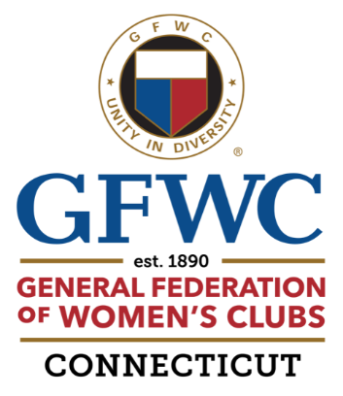

Call to North Central District Day
Saturday, April 13, 2024

“The Power of Volunteering”

Elizabeth’s Restaurant
4 Prospect Hill Road, East Windsor

Donna Recknagel, District President
Jeanne Kehoe, Assistant District President

8:30 Set-up Photo Contest and Raffles

9:00 Registration; Coffee & Tea; Purchase of Raffle & 50/50 Tickets

9:45 Call to Order
Reports of GFWC/CT Officers
Presentation of District Awards & 50-year Anniversary Pins
Club Presidents’ Reports
Speakers on Domestic Abuse from Interval House of Hartford
and The Network; Q&A to follow
Voting on Distribution of Remaining Funds

11:30 Social Time; Cash Bar
Viewing of Photo Contest
Final Purchase of Raffle & 50/50 Tickets (Ends at 11:45)

12:00 Expression of Thanks
Buffet

1:15 Meeting Reconvenes
Entertainment - Enjoy Club Skits
Report of the Nominating Committee for 2024-2026;
Election
Installation of District President & Assistant District President
Announcement of Photo Contest Winners
Announcement of Raffle & 50/50 Winners

3:00 Adjournment

GFWC
It’s a
VOLUNTEER
THING!

